APPLICANT(S) NAME(S): BUILDING/PROGRAM

NKSD PROCEDURE MANUAL | APPLYING FOR GRANT AWARDS GRANT CHECKLIST | BUSINESS OFFICE

A grant is a written agreement representing the voluntary transfer of money or other assets by the sponsor in exchange for the specifically detailed performance of services. Grants usually require some form of financial and/or technical reporting by the district as to the actual use of the money/assets involved.

After identifying a grant of interest, use the checklist below to assist in the process.

Gather all grant documentation, including the following:
Application
Grant Requirements – Is fund matching required? What is the source of the funds? Grant Reporting Requirements

Please check this box affirming you obtained verbal or email approval for your proposal from your Supervisor/Principal (principal will sign later)

Date:
Supervisor/Principal Signature Print Name

Scan and send all approved documents, ELECTRONICALLY TO Carmen Belleci, CBelleci@NKschools.org

District Approval Process

Kimberly Kinzer: Teaching and Learning | Lori Buijten: Special Ed
Craig Barry: Secondary Ed/Student Svcs/Athletics | Valerie Anderson: English Language Learning
Gwen Lyon: Elementary Ed | Rachel Davenport: HR/Technology
John Waller: CTE/Safety | Jason Rhoads: Business Operations

Date:
Administrator in Charge Signature

Final Review by Business office and to determine if Board Approval is required.

Date:
Business Office Signature

Grant returned to school/department to be submitted to agency

If the grant is approved, coordination will occur with the business office and grant manager to track the grant expenditures and seek reimbursement.
Grant application 8.26.19 NK SCHOOLS FOUNDATION

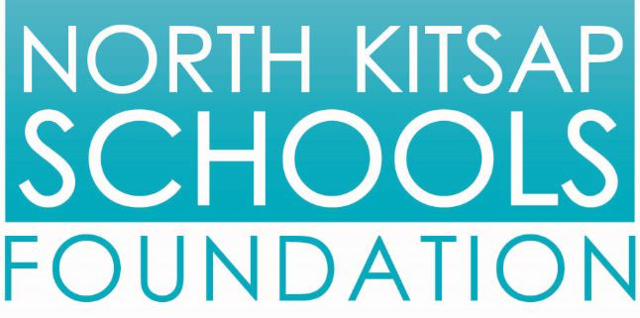 | Grant Application  2021-2022 School Year | FOR NKSF USE

Applicant Name(s):
School/Program/Team Name:
Primary Contact Information: | phone number:
 | e-mail:

Amount Requested: | $

Description of the materials/program(s) for which you are seeking funding

Purpose and goals of program or materials, including how the request fits within the foundation’s areas of emphasis and academic standards

Is this program new or ongoing?
Will you have building resources next year to continue/sustain it?

Budget – Please include an itemized (and prioritized, if appropriate) list including any material, shipping and tax costs. Attach estimates, information or pictured examples if desired.

Please list any additional sources of funding for the program

Please list the number and grades of students being served

What is the timeline for this program/material’s implementation? (expected date of use or start/end)

How will you measure the program’s success?

Please indicate how will you publicize the Foundation’s support (e.g. teacher website, school newsletter, parent letter, inscription on materials, newspaper, etc.)
Please direct questions to nkschoolsfoundation@gmail.com

